Peter Julius M. Estacio
Grouped with:
Augusto Gabbriel M. Calilung
Rafael Luis Mari R. Lambo
ENGG 27.01 - M
February 23, 2026

Project 1: Fixed-Point Approach for Finding Roots of Polynomials

A C++ program was developed to demonstrate the use of the fixed-point approach to find the root of a polynomial. By reading a valid polynomial file and extracting its contents, it can devise a fixed-point form of the equation x = g(x) for each non-constant term of the original function f(x) = 0. The fixed-point form is found by isolating the non-constant term and dividing the whole function in such a way that only x remains on one side of the equation. Specifically, for a function f(x) = 0 with non-constant term ax^{n}, x is isolated on one side by first transposing the term then dividing the whole function by -ax^{n-1}, as shown in the equations below.
f(x) = 0
f(x) - ax^{n} = -ax^{n}
$$\text{g(x) =} \frac{\text{f}\left(\text{x}\right)\text{-} {\text{ax}}^{\text{n}}}{\text{-}{\text{ax}}^{\text{n-1}}}\text{=} \text{x}$$
This is implemented in the code in the screenshot below. All other terms for this iteration are first calculated for within the for loop then stored in the double g_x. Then, the non-constant term in question is isolated by dividing g_x by the term -a * x^{i-1}, where the coefficient a is stored in the double* equation, and the integer i is an iterator representing the degree of the function. This is executed along with the fixed-point calculations for all non-constant terms, producing multiple fixed-point forms for the same equation depending on the degree of the initial function. It must be noted that this produces a rational function g(x) where x ≠ 0, for which the program makes sure to validate user input.
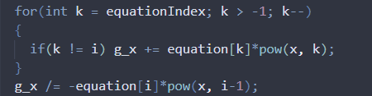
screenshot - how the application obtains the equation for the fixed-point iterations

Shown below are sample screenshots of the program being run using the basic test parameters. The program can read the polynomial file, extract its contents, and it’s shown to iterate through all non-constant terms by degree to calculate for the roots using the fixed-point approach. It is also demonstrated that the program will iterate until the estimates diverge, or the estimates converge to a value to the maximum precision stored in a double. The contents of the polynomial file “test” used during runtime are also shown below.
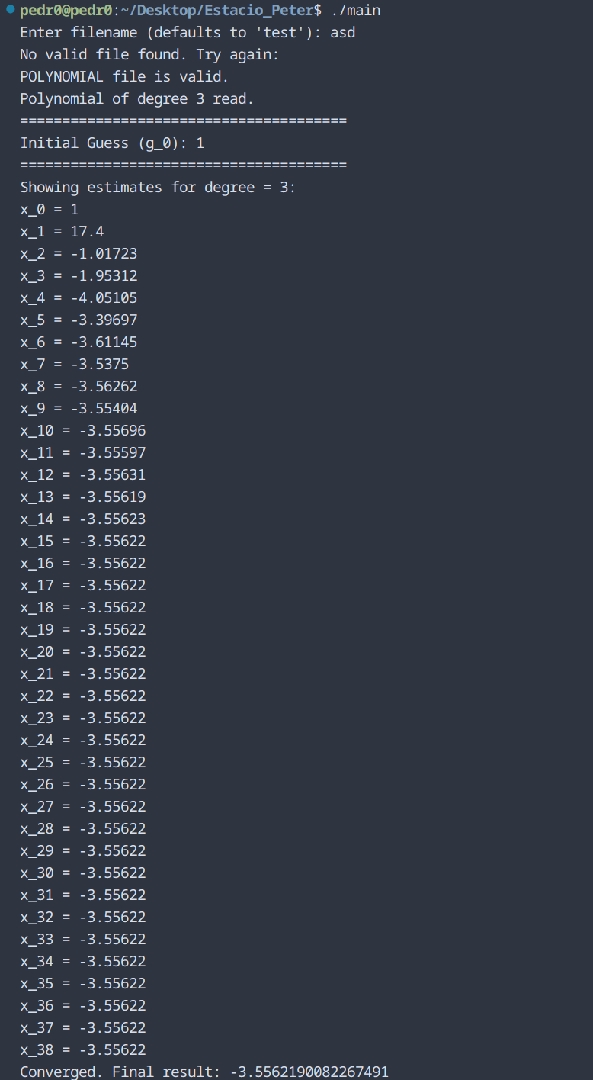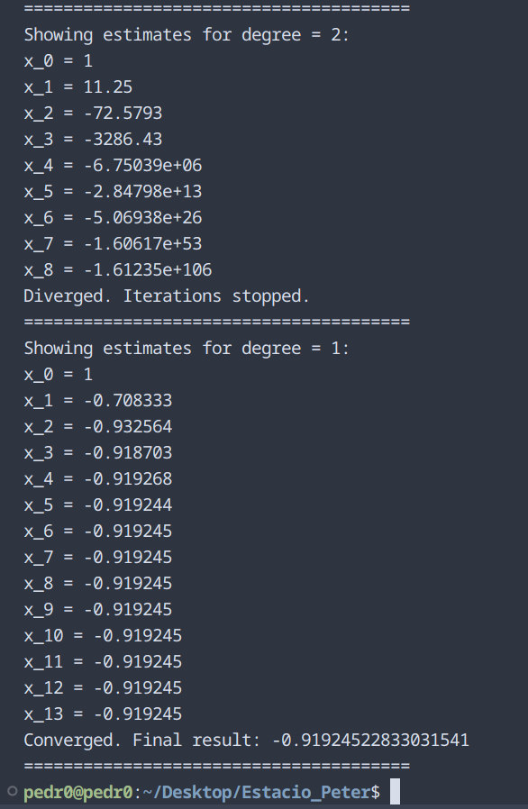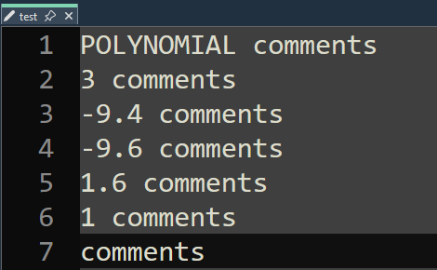
sample screenshots – program executable run with example results, and polynomial file used
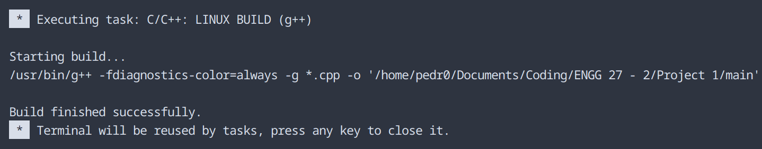
sample screenshot – compilation on Visual Studio Code
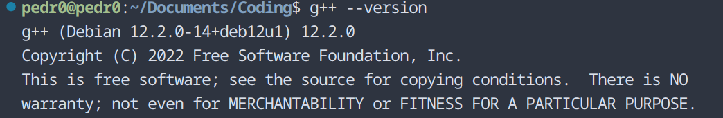
compiler version – g++ (Debian 12.2.0-14+deb12u1) 12.2.0
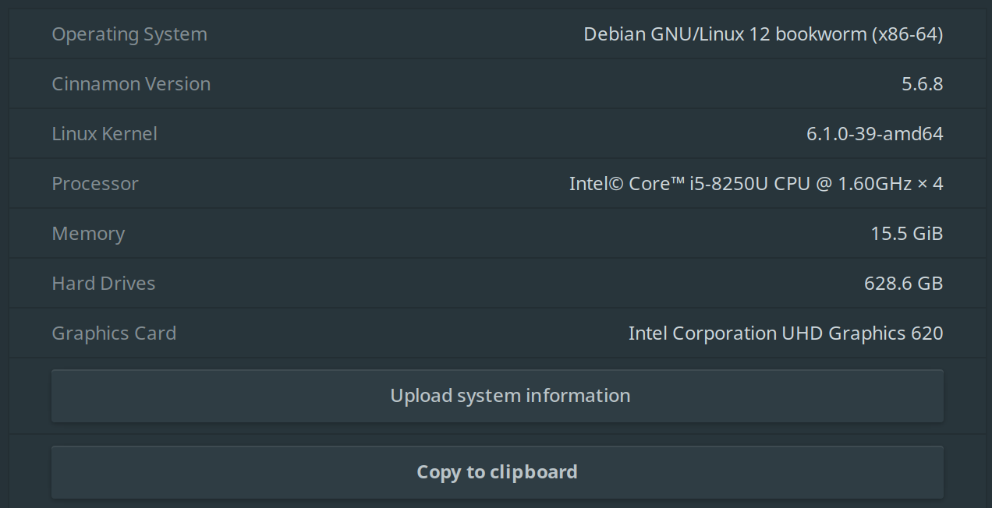
operating system – Debian 12 bookworm, Cinnamon version 5.6.8
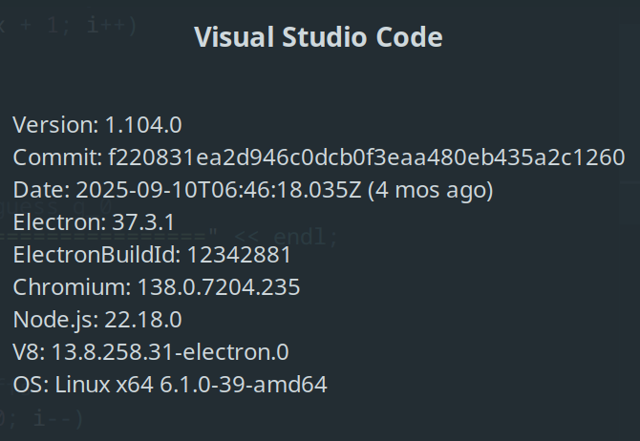
IDE – Visual Studio Code ver 1.104.0

Project Evaluation – Fixed-Point Approach for Finding Roots of Polynomials
Item | Points | Rubrics
early work | 8/8 | (all or nothing)  8: at most 10% of the code in the final implementation differs from that in early work submission
implementation and testing environment report | 4/4 | 4 – all instructions followed correctly
user interface: input file | 4/4 | 4 – appropriate user interface provided
polynomial file | 8/8 | 8 – application properly parses polynomial files
documentation of fixed point iteration | 32/32 | 32 – properly working and clearly documented implementation of fixed point iteration
convergence | 16/16 | 16 – all instructions related to convergence are properly implemented
divergence | 16/16 | 16 – divergence is always detected properly
polynomial file | 4/4 | 4 – correctly prepared polynomial file
program output | 4/4 | 4 – output produced according to instructions
self-evaluation | 4/4 | 4 – self-evaluation accurate (or evaluating this item leads to an error)
total | 100/100

